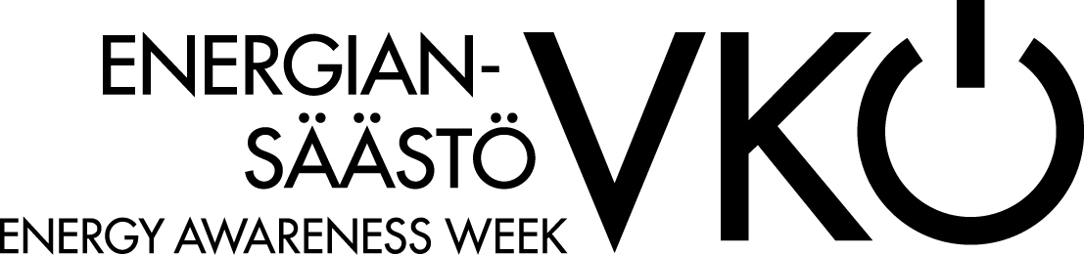

4 SMART TIPS FOR SAVING ENERGY IN YOUR HOME

Easily save when showering
2 minutes = 24 liters of water = 0,2€
10 minutes = 120 liters of water = 1,0 €
The share for warm water use is 40% - and it is expensive

Check the temperature from the thermometer, not from radiator.
The radiator don´t have to glow heath all the time, not even in the winter. Observe the room thermometer to keep your room temperature at 21-22 degrees. Don´t air the room if adjusting the radiators thermometer is enough.
1 degree in temperature = 5% in the bill.

Look in the toilet
One leaking toilet seat will flow away 260 cubic of clean water. That could increase the water- and wastewater duty by a thousand for one apartment.

Don´t feed the electricity glutton
Obtain only necessary and energy mingy device to your home. Turn them off when not using. Serviced and clean home electronics work right, effective and safe.
Energy mingy saves 5% just by turning off devices.

